

**CLOTHING SHOP Project Report**

**Software Requirement Specification**

– Hanoi,May 2022–

Contents

1. Introduction 3

1.1 Purpose 3

1.2 Document Conventions 3

1.3 Project Scope 3

1.4 References 3

2. Overall Description 3

2.1 Product Perspective 3

2.2 User Classes and Their Use Cases 4

2.2.1 Visitor 4

2.2.2 Customer 4

2.2.3 Seller 4

2.2.4 Administrator 4

2.3 Operating Environment 5

2.4 Dependencies 5

Dependencies: 5

2.5 Business rules (Updating…) 5

3. Functional Requirements 5

3.1 System Functional Overview 5

**3.4****View Product Detail** 13

**3.5****Change Amount** 14

**3.6****Delete Product** 15

**3.7****Register** 16

4. Data Requirements 17

4.1 Logical Data Model (Updating…) 17

4.2 Data Dictionary (Updating…) 17

4.4 Data Integrity and Retention 17

5. External Interface Requirements 17

5.1 User Interfaces 17

The Clothing Shop Ordering System screen displays shall conform to the User Interface Design and User Experience Design 17

5.2 Software Interfaces (Updating…) 17

5.3 Hardware Interfaces 17

5.4 Communications Interfaces 17

6. Nonfunctional Requirements 18

6.1 Performance Requirements 18

6.2 Security 18

7. Other Requirements 18

Appendix A: Analysis models 19

Context Diagram 19

State Transition Diagram for Order 19

# Introduction

## Purpose

This document describes the requirements for website, which provides services and supplies clothes for purchaser. Types of reader this document is intended for: developers, project managers, testers, customers, etc...

## Document Conventions

The functional requirements for this project are organized by users.

## Project Scope

The website will provides common information clothes for the customers. This website also will permit purchasers to pick up clothes from the company online to be delivered to specified locations.

## References

Existing web sites used as models for ideas regarding the functionality documented and user interface style here include:

* https://www.zanado.com
* http://www.viviane.vn
* http://www.yes24.vn
* http://www.penda.vn

# Overall Description

## Product Perspective

The 4.0 revolution is approaching, that's why information technology has been playing a huge role today , and it will be a challenge when an organization or any area of life lacks a computer system. Online shopping is a trend that provides all the details about customers, products, orders, etc… Specifically, this Online Shopping System is a kind of online shop where a seller can sell his/her products or services and customers can buy. Selling online has been easier, faster, or more convenient than with traditional selling.. We have developed this mini project Online Shopping System on Java, JSP, and SQL, all HTML code will conform to the HTML 5.0 standard and the project will runs over the Glassfish 4.1.1 Server. In case something bad happens, including system failure or negative feedback,… the administrator will be able to maintain and modify the site. This system supports the below types of user… (see more in section 2.2)

## User Classes and Their Use Cases

### Visitor

A visitor is someone who visit the website to learn more information about clothes sold on this website. Use cases:

1: View all products

2: Search for a product

3: View product’s detail

4: Read blog

### Customer

A customer is someone who orders a product from the website. Use cases:

1: Login

2: View all products

3: Search for a product

4: View product’s detail

5: Add product to cart

6: Checkout

7: Check order status

8: Cancel order

9: Rate product

10: Give feedback

11: Read blog

### Seller

A seller is someone who has the responsibilities to manage the website’s products and the business important data

1: Create a product

2: Modify a product

3: Delete a product

4: Add promotion detail

5: View dashboard

### Administrator

An administrator is the person who has the responsibility to manage users of website. Use cases:

1: Change users’ information

2: Delete an user

## Operating Environment

The website will be compatible with standard web browsers on Computer and Smart Phone platforms.

## Dependencies

## Dependencies:

* User’s environment (Browser)
* User’s devices (Computer, Smart phone,…)
* External libraries

## Business rules (Updating…)

## 3. Functional Requirements (Updating…)

### 3.1 System Functional Overview

#### a. Screen Flow

User

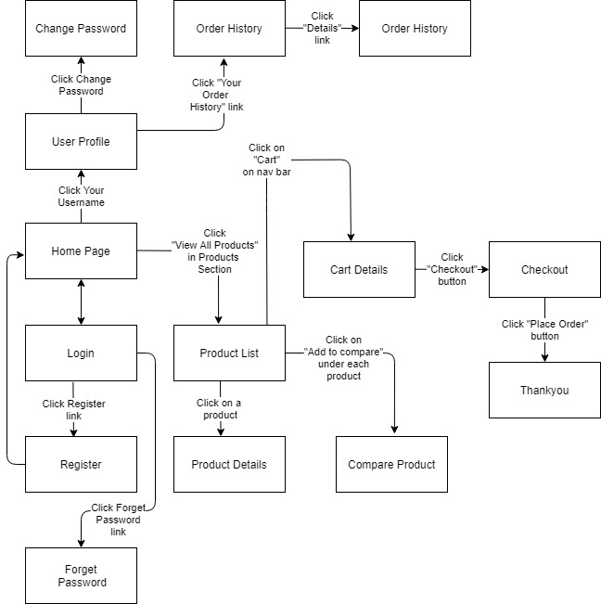

Figure 1-1: Screen Flow for User

Admin

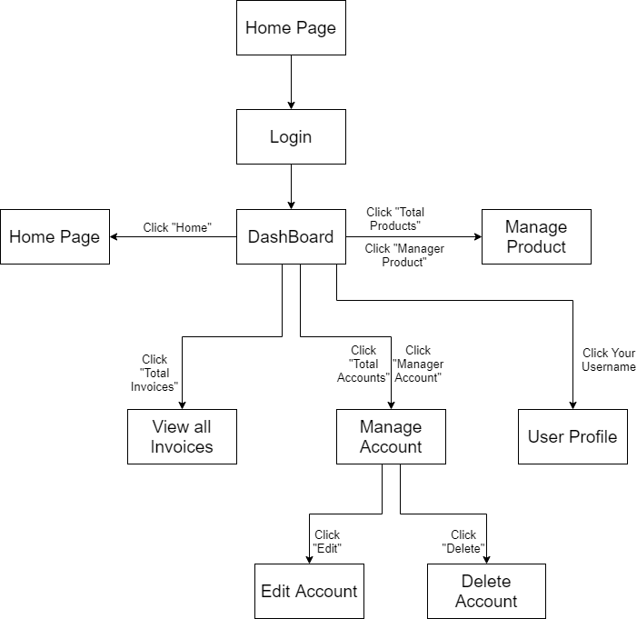

Figure 1-2: Screen Flow for Admin

Seller

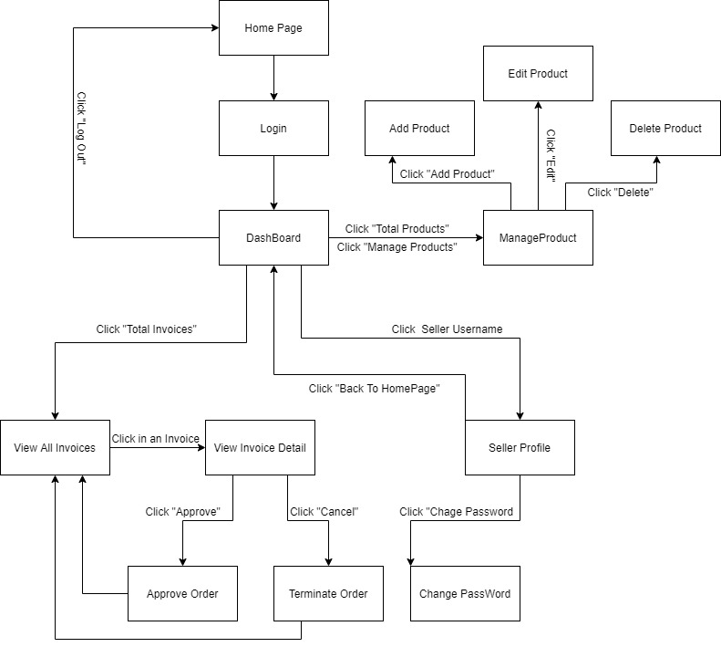

Figure 1-3: Screen Flow for Seller

#### b. Screen Details

|  |  |  |  |
| --- | --- | --- | --- |
| **#** | **Feature** | **Screen** | **Description** |
|  | Search & Filter Product | Home Page | Search for a Product by name or filter it by category |
|  | View Product Detail | Product Details | Display detail information of Product |
|  | Change Amount | Cart Details | Plus or Minus the Amount of a Product in Cart |
|  | Delete Product | Cart Details | Delete a Product in Cart |
|  | Delete Cart | Cart Details | Delete all the Product in Cart |
|  | Login | User Login | User Login to the System |
|  | Register | User Register | User Register for an account |
|  | View User List | Users List [Admin] | Admin View the list of all Accounts in the System |
|  | Edit User | Users List [Admin] | Admin Edit information of an Account |
|  | Delete User | Users List [Admin] | Admin Delete an Account from the System |
|  | Add Ship Information | Cart Completion | User enter all shipping information for delivery |
|  | Change Ship Information | Cart Completion | User can change the existing shipping information for delivery |
|  | Reset Password | Reset Password | When user forget password, send a verification code through Email for user to reset password |
|  | Change Password | Change Password | Change user’s old password with new password |
|  | User Profile | User Profile | User views information about his account |
|  | My Orders | My Orders | User views the history of all orders he made |
|  | Order Information | Order Information | User views detail history of a specific order |
|  | View Product List | Products List [Sale] | Seller views all of Products that he sells |
|  | Sale Dashboard | Sale Dashboard [Sale] | Seller views Statistic of the sale of his products |
|  | Orders List | Orders List [Admin] | Admin views list of all of 2orders |
|  | Order Details | Order Details [Sale] | Seller views the detail of 1 of his orders |
|  | View Feedback | Feedback | Customer views all the Feedbacks about a Product |
|  | Send Feedback | Feedback | Customer writes and send a Feedback about a Product |
|  | Blogs List | Blogs List | Customer views the list of all Blogs |
|  | Blog Details | Blog Details | Customer views the Detail information of 1 Blog |
|  | View Notification | Notification | User views the list of new Notifications |
|  | View all Notification | Notification | User views the list of all Notifications |
|  | Mark as Read | Notification | User mark all the new Notification as read |
|  | Error | Error | Show in case there’s an Error occurs |

Table 1-1: Screen Details

#### c. Screen Authorization

| **Screen** | **Guest** | **User** | **Seller** | **Admin** |
| --- | --- | --- | --- | --- |
| Home Page | x | x |  |  |
| Product Details | x | x |  |  |
| Cart Details |  | x |  |  |
| User Login | x |  |  |  |
| User Register | x |  |  |  |
| User Authorization | x |  |  |  |
| Users List [Admin] |  |  |  | x |
| Cart Completion |  | x | x | x |
| Reset Password |  | x | x | x |
| Change Password |  | x | x | x |
| User Profile |  | x | x | x |
| My Orders |  | x |  |  |
| Order Information |  | x |  |  |
| Products List [Admin] |  |  |  | x |
| Sale Dashboard [Sale] |  |  | x |  |
| Orders List [Sale] |  |  | x |  |
| Order Details [Sale] |  |  | x |  |
| Feedback | x | x |  |  |
| Blogs List | x | x |  |  |
| Blog Details | x | x |  |  |
| Notification |  | x | x | x |
| Error | x | x | x | x |

In which:

* Guest: Customer who has not yet logged in to the site
* User: Customer who has an account an has logged in
* Seller: People who sell products in the shop
* Admin: People who manage the shop

#### d. Non-Screen Functions

|  |  |  |  |
| --- | --- | --- | --- |
| **#** | **Feature** | **System Function** | **Description** |
| 1 | Remember Me | Login | System store user’s login account and password in cookies for future re-login |
| 2 | Add To Cart | Home Page & Product Detail | User Click “Add To Cart” to add this Product to Cart |

#### e. Entity Relationship Diagram (Updating…)

#### The database is just enumerating entities and data for each entity. Details of the data can be viewed in the attached 'QuanaoDatabase' folder.

**Entities List (Updating…)**

|  |  |  |
| --- | --- | --- |
| **#** | **Entity** | **Description** |
| 01 | TypeOfProduct | Loại sản phẩm |
| 02 | NameOfProduct | Tên sản phẩm |
| 03 | CodeOfProduct | Mã sản phẩm |
| 04 | Price | Giá thành của sản phẩm |
| 05 | Quatity | Số lượng sản phẩm hiện có ở shop |
| 06 |  |  |
| 07 |  |  |
| 08 |  |  |
| 09 |  |  |
| 10 |  |  |
| 11 |  |  |
| 12 |  |  |
| 13 |  |  |
| 14 |  |  |
| 15 |  |  |
| 16 |  |  |
| 17 |  |  |
| 18 |  |  |

* 1. **View Product Detail**
* Function description:
  + Role: Guest, User
  + Purpose: User can view all the detail information of a Product
* Screen layout:

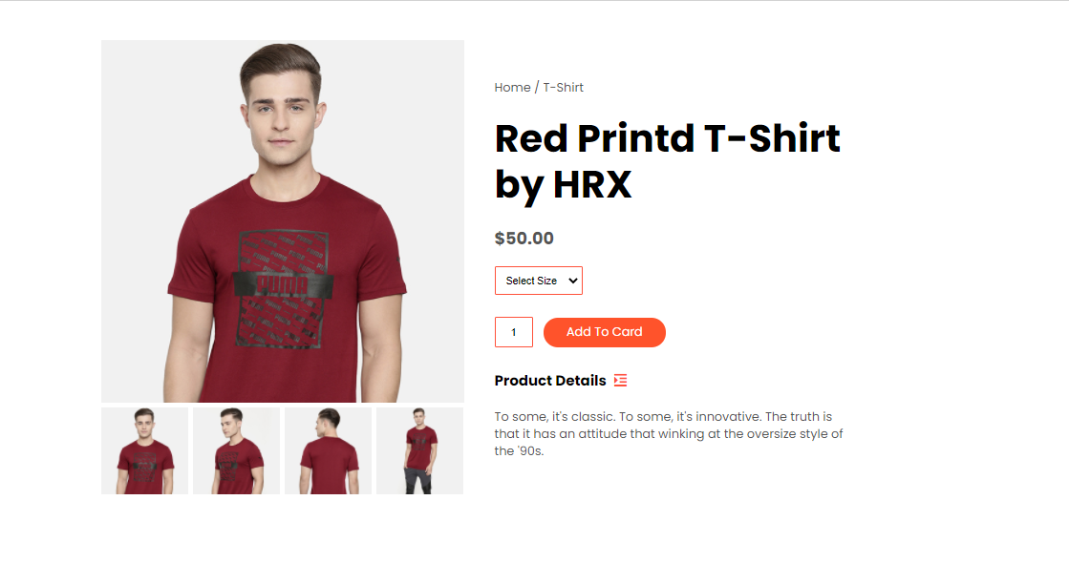

* 1. **Change Amount**
* Function description:
  + Role: User
  + Purpose: User can change the amount of the Product they want to buy
* Screen layout:

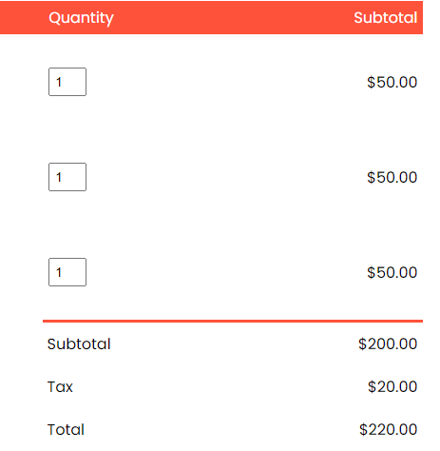

* 1. **Delete Product**
* Function description:
  + Role: Guest
  + Purpose: User can Delete a Product from their Cart
* Screen layout:

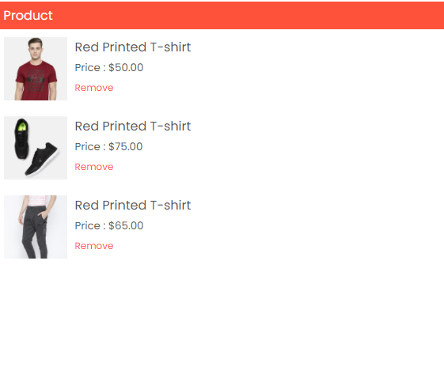

* 1. **Register**
* Function description:
  + Role: Guest.
  + Purpose: Provide a form for customer to register an account.
* Screen layout:

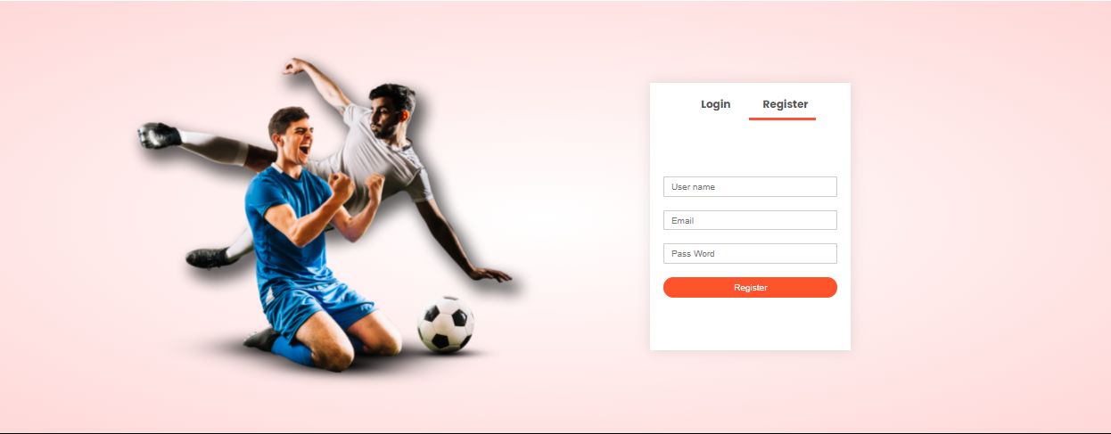

# 4. Data Requirements

## 4.1 Logical Data Model (Updating…)

## 4.2 Data Dictionary (Updating…)

## 4.4 Data Integrity and Retention

## Clothing Shop system will store customer orders so that when customers want to see what they bought last time.

## 5. External Interface Requirements

## 5.1 User Interfaces

## The Clothing Shop Ordering System screen displays shall conform to the User Interface Design and User Experience Design

## 5.2 Software Interfaces (Updating…)

+ Clothing Shop Account Checking system

+ Upload existing user data in the system through a programming interface

+ The system automatically checks what state the account is in in the UserStatus. If you belong to Locked, you will not be able to log in and have to create a new account, and if you belong to Unverified, you must go to gmail to verify your account.

+ Clothing System will transmit the quantities of product items ordered through a programmatic interface.

+ The Clothing system will display the quantity left in stock for the buyer. If there is no stock in stock, the user will not be able to place an order for this product.

## 5.3 Hardware Interfaces

No hardware interfaces have been identified.

## 5.4 Communications Interfaces

Clothing Shop shall send an email to the Customer to report any problems with the product order or delivery.

# Nonfunctional Requirements

## Performance Requirements

+ The system will provide continuous service, which means the shop will work 24/7, with an estimated average session duration of 30 minutes.

## Security

+ The website will use standard Web security protocols when transferring any private information regarding a Guest, Customer, or Seller.

+ Users will be required to log on to the Clothing Shop website for all operations except viewing home page, blog, product list and viewing a specific product.

+ Only the Admin will be permitted to confirm an order, only the Customer will be permitted to confirm an order has been delivered.

+ The system will permit Customer to view only orders that they placed and give a feedback on each products in those orders.

# Other Requirements

+ If the connection between the user and the Clothing Shop is broken prior to a new order being either confirmed or terminated, the Clothing Shop will enable the user to recover an incomplete order and continue working on it.

+ All confirmation code and order information will be send via user’s email.

+ The users email and user name cannot be changed.

# Appendix A: Analysis models

## Context Diagram

*GMAIL*

User email address, mail content

**ONLINE SHOP**

## State Transition Diagram for Order

